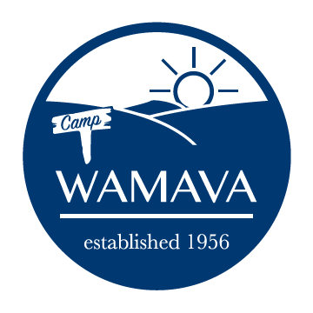
2022 Junior Staff Application

The primary responsibility of junior staff will be keeping the kitchen and campgrounds clean. They will also have the opportunity to serve other needs of camp. Applicants must be at least 15 years old by the calendar year’s end AND a rising 10th, 11th, or 12th grader.

Junior staff are expected to arrive by 4pm on Sunday of their assigned week through 9am Saturday.

Contact Information
Name
Email
Phone
Birthday (mm/dd/yy)
Grade (as of Fall 2022)
Parent/Legal Guardian Name
Parent/Legal Guardian Email

Week of Availability to Junior Staff

If more than one week available, rank by preference (1 = highest)
Week 1 (Jun 19 – Jun 25) | (_)
Week 2 (Jun 26 – Jul 2) | (_)
Week 3 (Jul 3 – Jul 9) | (_)
Week 4 (Jul 10 – Jul 16) | ( )

Please email completed application as a PDF or Word attachment to director@wamava.com

You must register for one week as a camper prior to submitting a junior staff application. After you submit the application, the director will send a confirmation email informing you of your assigned volunteer week. Thanks for volunteering at Camp WaMaVa!

