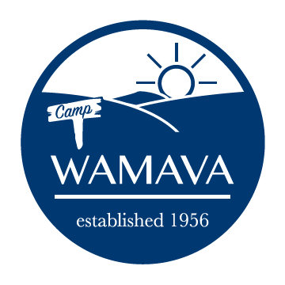
2020 Junior Staff Application

The primary responsibility of junior staff will be keeping the kitchen and campgrounds clean. They will also have the opportunity to serve other needs of camp. Applicants must be at least 15 years old by the calendar year’s end AND a rising 10th, 11th, or 12th grader.

Junior staff are expected to arrive by 4pm on Sunday of their assigned week through 9am Saturday.

Contact Information
Name
Email
Phone
Birthday (mm/dd/yy)
Grade (as of Fall 2020)
Parent/Legal Guardian Name
Parent/Legal Guardian Email

Week of Availability to Junior Staff

If more than one week available, rank by preference (1 = highest)
Week 1 (Jun 21 – Jun 27) | (_)
Week 2 (Jun 28 – Jul 4) | (_)
Week 3 (Jul 5 – Jul 11) | (_)
Week 4 (Jul 12 – Jul 18) | ( )

Please email completed application as an attachment to director@wamava.com

You must register for one week as a camper prior to submitting a junior staff application. After you submit the application, the director will send a confirmation email informing you of your assigned volunteer week. Thanks for volunteering at Camp WaMaVa!

